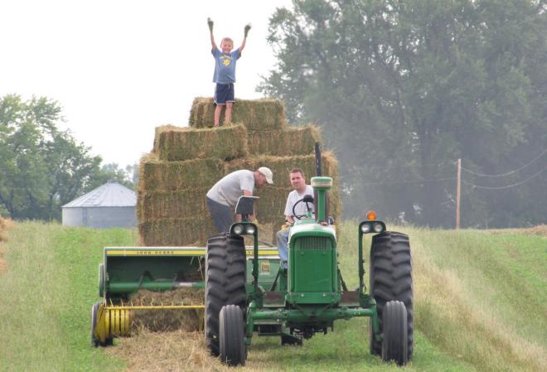

Light Refreshments Served

**FEBRUARY 27TH 6 - 8:30 PM** [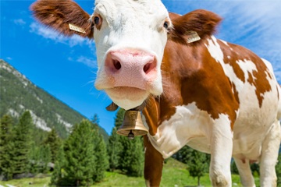](https://www.google.com/url?sa=i%26rct=j%26q=%26esrc=s%26source=images%26cd=%26cad=rja%26uact=8%26ved=2ahUKEwibpPe2zpbgAhUPWN8KHXPdDmUQjRx6BAgBEAU%26url=https:/science.howstuffworks.com/science-vs-myth/what-if/what-if-cows-didnt-exist.htm%26psig=AOvVaw3c4wtMRSb9c4lxgYP_cYya%26ust=1548975670622228)**:30 PM**

*Contact For More Information*

Mark Christensen:

Chairman of East Lyme Agribusiness Sub-Committee of Conservation Commission

Phone: (860)-442-1292 (voicemail)

Email:

GreenAcresInc@sbcglobal.net

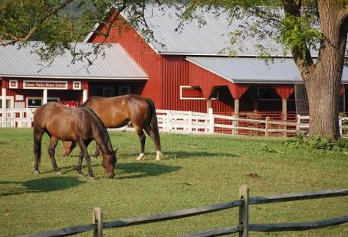

Come to a FREE seminar hosted by East Lyme Agribusiness Sub-Committee, at East Lyme Library

39 Society Road Niantic, CT

Wednesday, Feb. 27th 6 - 8:30 PM!

Snow Date: Monday, March 11th 6 - 8:30 PM)

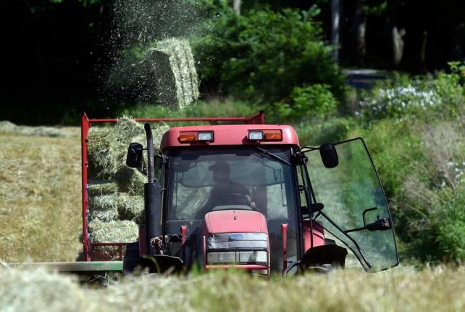

Guest Speakers Include:

Joan Nichols of CT Farm Bureau

Kathleen Dorherty of CT Farmland Trust

**Get Paid To Keep and Preserve Your Farm!**